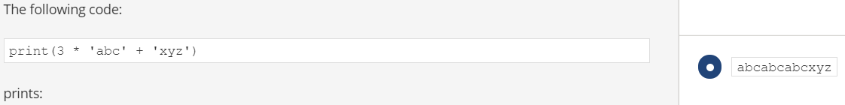

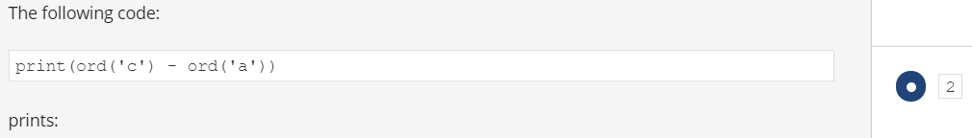



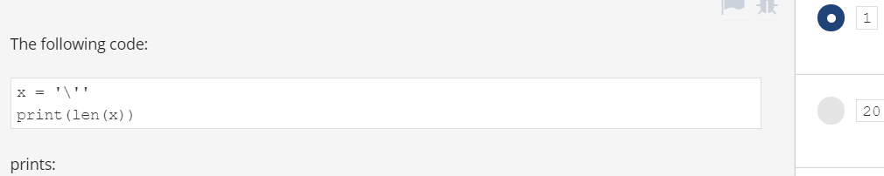

<https://www.premiumexam.net/pcap-programming-essentials-in-python/pcap-programming-essentials-in-python-quizzes-module-4-test-answers/>

<https://www.premiumexam.net/pcap-programming-essentials-in-python/pcap-programming-essentials-in-python-quizzes-summary-test-2-answers/>